

Faculty of Engineering

Department of Mechanical and Mechatronics Engineering



**Prototyping a Stretchable Electronic Display Mechanism**

**Prepared For**



King Abdullah University of Science and Technology

Thuwal, Saudi Arabia

**Prepared By**

Kelvin Chow

3B Mechanical Engineering

Student ID: 20466985

May 9, 2016

48 Grover Hill Ave.

Richmond Hill, Ontario

L4S 1T6

May 9, 2016

Professor Michael Collins,

Associate Chair Undergraduate Studies, Mechanical Engineering

Department of Mechanical and Mechatronics Engineering

University of Waterloo

Waterloo, Ontario

N2L 3G1

Dear Professor Collins,

This report, entitled “Prototyping a Stretchable Electronic Display Mechanism”, was prepared as my 3B work term report for the King Abdullah University of Science and Technology (KAUST). This is my third and final work term report. The objective of this report is to detail the prototype of a stretchable electronic display that I designed and 3D printed.

King Abdullah University of Science and Technology, established in 2009, is located in Saudi Arabia. It is home to state of the art facilities and research centres to aid faculty and students with their research in fields such biological science, environmental science, electrical engineering, computer engineering, and physical sciences.

During my time at KAUST, I was a part of the Integrated Nanotechnology Lab (INL) and the Integrated Disruptive Electronic Applications (IDEA) Lab under the supervision of Dr. Muhammad Mustafa Hussain. The focus of the research group is to use complex fabrication processes to produce flexible electronics with the vision of changing how electronics are being used today.

This report was written entirely by me and has not received any previous academic credit at this or any other institution. I would like to thank the INL and IDEA lab research group for their support and guidance throughout my internship. Specifically, I would like to thank Dr. Hussain for giving me direction and guiding me through this project and my mentor Marlon Diaz who helped me on a day-to-day basis when I needed assistance with operating the 3D printer or general design consultations. Other research group members who played a significant role in my project were Irmandy Wicksono and Adrian Sepulveda. I received no further assistance.

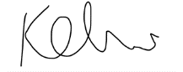Sincerely,

Kelvin Chow

Student ID 20466985

3A Mechanical Engineering

Table of Contents

Table of Contents i

List of Figures ii

Executive Summary iv

1.0 Introduction 1

2.0 The Original Stretchable Display Prototype 4

2.1 The Original Concept of the Display 4

2.2 Determining the Constraints of Motion of the LED Array 5

2.3 Design of the Uniformly Expanding Apparatus 6

2.4 Refinements to the First Design 11

3.0 Second Design Iteration of the Stretchable Display 15

3.1 First Approach to the Solution 15

3.2 Second Approach: A Complete Redesign 17

4.0 Third Prototype of the Stretchable Display 20

4.1 Visualizing the Configuration 20

4.2 Connecting the Four Layers Together 21

4.3 Implementing the Second Prototype with the Current Prototype 25

4.4 Bringing the Design to Real Life 26

4.5 Adding “Pixels” 29

4.6 Adjustments to the Prototype after the First Print 31

5.0 Conclusions 35

6.0 Recommendations 36

6.1 Automated Prototype 36

6.2 Reducing Prototype Thickness 36

6.3 Further Stretchability 36

6.4. Increasing “Pixel” Density 37

7.0 References 38

List of Figures

Figure 1: Stretchable LED display with serpentine interconnects. 4

Figure 2: Simplified representation of the two states of the LED array. (a) Contracted state. (b) Expanded state. 5

Figure 3: Movement of the LEDs. Circles represent the starting point of the collapsed array, with the arrow showing the movement of each individual square. Square 1 is anchored. 6

Figure 4: 3D CAD Model of base track design. Squares move along the 5 tracks, with one square anchored in the bottom left corner. 7

Figure 5: View of the bottom of square 2. The C profile of the square allows it to move along the square track of the base. 8

Figure 6: Individual square platforms with guide arms attached. (a) Square 9 with long guide arms in X and Y direction. (b) Square 8 with short guide arm in Y direction. 9

Figure 7: Full 3D CAD assembly of prototype 1. (a) Assembly in contracted state. (b) Assembly in expanded state. 10

Figure 8: 3D printed model of the first prototype. Movement is controlled by square 9. 10

Figure 9: Side views of (a) square platform and (b) base track. 11

Figure 10: Updated cross section of (a) square and (b) track. (c) Mated assembly of square and track. 11

Figure 11: 4 by 4 model of the prototype. (a) CAD model. (b) 3D printed mode overlaid with LEDs. 12

Figure 12: Updated design of the guide arms. 13

Figure 13: Updated 4 by 4 stretchable display prototype with motor configuration. 13

Figure 14: 4 by 4 array of LEDs attached to square platforms connected with 3 by 3 hidden array of LEDs. 14

Figure 15: Areas from the first prototype that need to be removed. 15

Figure 16: A Drawer slide mechanism (eDirectHardware.com) [12]. 16

Figure 17: CAD model of revised partial track. (a) Contracted state. (b) Transition to an expanded state with a shortened base track (beige component). 16

Figure 18: (a) Guide arms for prototype 2. (b) Cross section view of guide arms. 16

Figure 19: Redesigned guide arms by changing locations. (a) Compact view. (b) Exploded view. 17

Figure 20: Updated track design for prototype 2. 18

Figure 21: Full 3D CAD model of prototype 2 of the stretchable display. (a) Compact state. (b) Expanded state. 19

Figure 22: 3D printed model of prototype 2. (a) Compact state. (b) Expanded state. The guide arms were adjusted in the model after the print for more support. 19

Figure 23: (a) Side view and (b) isometric view of a simplified representation of the third prototype in compact state. 21

Figure 24: Mechanical link connecting between one square on the top layer to a square on a secondary layer 22

Figure 25: 6 link connections between the top layer and secondary hidden layer. 22

Figure 26: A square platform on the third layer, which connects to both the top layer and fourth layer of platforms. 23

Figure 27: All square platforms connected using 16 links. 23

Figure 28: Assembly showing tight gaps between the third layer (blue) and the fourth layer (yellow). 24

Figure 29: CAD model of third prototype at (a) compact state, (b) transition state, and (c) expanded state. 25

Figure 30: Third prototype updated with the base foundation from the second prototype. 26

Figure 31: (a) G-code simulation of 3D printed component with support material compared with (b) 3D CAD model. 27

Figure 32: All 3D printed components ready for assembly of third prototype. 28

Figure 33: Part of the assembly showing the staples at the pivot points.. 28

Figure 34: Guide tracks connecting two square platforms. 29

Figure 35: Fully assembled third prototype. The prototype was able to transition from (a) compact to (b) expanded state by pulling on the corners of the prototype. 29

Figure 36: (a) Bottom side of prototype with partial wiring. (b) Single LED used for this prototype. 30

Figure 37: Circuit diagram of stretchable display prototype. 30

Figure 38: Stretchable Display prototype with all LEDs turned on. 31

Figure 39: (a) Square platform mated with another through revised guide tracks. (b) Exploded view. 32

Figure 40: Un-level square platforms when platform was expanded. 33

Figure 41: Partial CAD model of the vertical actuator support mechanism. 34

Figure 42: 3D printed vertical actuating support subassembly. (a) Compact state. (b) Expanded state. 34

Figure 43: Final stretchable display prototype transitioning from (a) compact to (b) expanded state by pulling on the corners. 34

Figure 44: Square platforms saturated with 9 LEDs each. 37

Executive Summary

When it comes to electrical displays, what comes to mind is a thin, box-shaped, rigid monitor. The concept of a stretchable electrical display is foreign to most. The few research groups that have published papers on stretchable displays had the common trend of embedding LEDs on flexible substrates. The stretchable display prototype presented in this report offers an unconventional approach.

The prototype was manufactured using a 3D printer. All components were made out of rigid material, polyactic acid (PLA). The design of the prototype focused on solving three different problems. The first was to create a uniformly expanding and contracting display in the X and Y direction. The second prototype focused on refining the geometry of the first prototype. The last prototype design was about maintaining “screen resolution” by having no gaps in between pixels when the display expanded.

By offering this unusual approach, the goal is to inspire others to think differently about the concept of a stretchable display. This display prototype is advantageous over other stretchable display prototypes in terms of structural support, maintaining display resolution, increased stretchability, and durability.

1.0 Introduction

In the digital age we live in today, electronic displays have become embedded in everyday life. The majority of consumer electrical devices require an electrical display to communicate with the user. The mainstream area of focus to improve the electronic display is on the display quality outputted by the screens. What is far less common, but potentially just as important for the future of electrical displays, is focusing on creating a transformable display. A display that could be stretched and manipulated into various configurations while still maintaining the same resolution would change how people interact with their electronic devices. There have been engineers and research groups around the world who are trying to change the appearance of the typical box-shaped electrical display. Curved screen televisions have become widely popular over the last couple of years to enhance viewing experience [1]. Samsung’s last two flagship smartphones have introduced the first mobile device with a curved edge as part of the display [2]. Screens with a curved geometry is innovative, but they are still physically rigid screens.

Samsung has taken it a step further from the curved screen phones and TV monitors. They have introduced a flexible screen that they expect to hit the market in the near future [3]. Flexible displays are not a new concept as many other electronics manufacturers have prototyped flexible display concepts [4] [5]. This flexible screen trends towards a future of electrical displays that are expanding outside the same rigid, box-shape display that the world has been so accustomed to over the last few decades.

For electrical displays, technology that is further away from being commercialized is the concept of a stretchable electronic display. Currently, there have been a few research groups presenting their concepts of stretchable display [6] [7] [8]. The approach from other research groups had a common theme of embedding LEDs on flexible substrates and flexing the substrates. With this approach, there would be a decrease in display resolution while flexed.

The objective of this report is to detail the process to create a unique stretchable display prototype. This report will outline three main design iterations for the prototype. It will discuss the design of the prototype and the manufacturing process of 3D printing that was utilized to physically create the prototype.

Two main tools were used to create the prototype. SolidWorks, a 3D computer aided design (CAD) software, was utilized to create the designs. It was also used to simulate the mechanics of motions of the designs.

The other tool was a Leapfrog XEED 3D printer. This 3D printer used fused deposition modeling (FDM) technology to print parts [9]. FDM uses an extruder to move a filament of material through a heated extrusion head. As the filament heats up, the material is pushed through a heated nozzle and deposited on to a print bed.

To prepare a CAD model for 3D printing, the design first needed to be converted to stereolithography file (.STL extension) [10]. This file contains only the geometry of the model. Then, using a third party application called Simplify3D, 3D printing parameters such as printing speed, temperature, layer height, and support material, could be adjusted for high quality prints. This software translates the 3D model from a .stl file to a .gcode file. G-code is a programming language that is compatible with 3D printers to control the printer [11].

2.0 The Original Stretchable Display Prototype

The final concept of the stretchable display was altered from what was originally conceived. This first prototype of the stretchable display mechanism was focused on uniform expansion and contraction.

2.1 The Original Concept of the Display

At the beginning, the prototype being built was merely intended to be a testing apparatus for an existing flexible LED display system similar to those presented by other research groups. It was a 3 by 3 array of LEDs with serpentine interconnects that allowed for the expansion of the LED array. An apparatus was required to uniformly expand the LED array in both X and Y directions. See Figure 1 for the LED array.

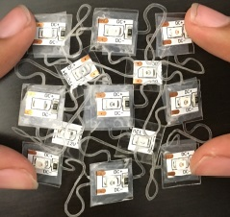

Figure 1: Stretchable LED display with serpentine interconnects.

.

From this figure, it can be seen how difficult it is to control all the pixels due to the serpentine connections. This was the need for creating a uniformly expanding apparatus.

2.2 Determining the Constraints of Motion of the LED Array

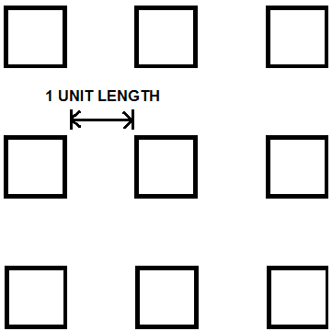There were two states for the LED array: expanded and contracted. See Figure 2 for a simplified representation of the LED system.

**(a)**

**(b)**

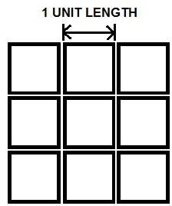

Figure 2: Simplified representation of the two states of the LED array. (a) Contracted state. (b) Expanded state.

The assumption for this design was that there was no gap between LEDs in the contracted state and there was a distance of one LED length between adjacent LEDs in the expanded state. For the expansion of the array, one LED needs to be anchored while the other eight LEDs move. The LED chosen to be the anchor point was the bottom right corner LED, which was arbitrarily chosen. With this anchor point in place, the movement of the eight LEDs could be determined. See Figure 3 for the movement required for each LED while transitioning states.

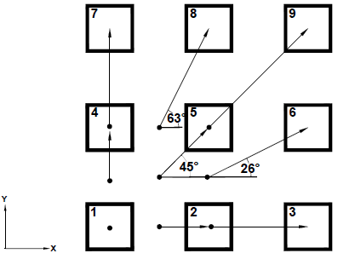

Figure 3: Movement of the LEDs. Circles represent the starting point of the collapsed array, with the arrow showing the movement of each individual square. Square 1 is anchored.

From this figure, it is shown that all eight moving LEDs undergo rectilinear motion simultaneously. All squares move from the start point and finish at the end point at the same time. Another important takeaway from this figure is that at any point in time, each row/column of 3 LEDs were always aligned in one plane. For instance, each row of LEDs would have the same Y coordinate. These two key points formed the basis of the apparatus design.

2.3 Design of the Uniformly Expanding Apparatus

Knowing the motion of each individual LED, one solution would be to attach every moving LED to its own motor. The motors could be programmed so that they moved together to form a uniformly expanding LED array. This design would probably work, but there were simpler solutions. Instead of using eight motors, the goal for this apparatus was to use one motor to control the complete system.

Each LED would be stuck on a square platform using tape. It would be easier to move the LEDs if they were on a rigid platform with a significant thickness. The size of a single LED was about 5x5 mm, and each platform was designed to be 15x15 mm.

The first key point in section 2.2 was that all the moving LEDs underwent rectilinear motion. The first concept of this design was to constrain the motion of each LED (and its corresponding square platform) so that they could only move along their rectilinear path. See Figure 4 for the base track design.

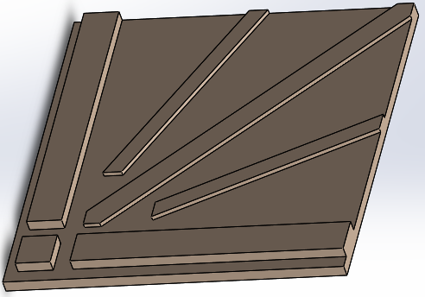

Figure 4: 3D CAD Model of base track design. Squares move along the 5 tracks, with one square anchored in the bottom left corner.

The tracks shown in Figure 4 were 2 mm extrusions from the large base square. These tracks constrain the movement of each individual square platform. See Figure 5 for the design of the bottom of the square platform.

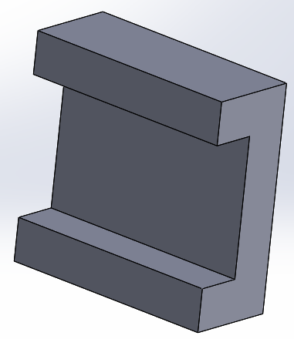

Figure 5: View of the bottom of square 2. The C profile of the square allows it to move along the square track of the base.

Every LED had 2 degrees of freedom (DOF): the X and Y direction. Nine LEDs meant the total degrees of freedom of the system was 18. By fixing one corner LED, that individual LED had 0 degrees of freedom. The base track design in Figure 4 eliminated 1 DOF for the eight moving LEDs because the LEDs could only move along the rectilinear path constrained by the track. This reduced the DOF of the system to 8. The goal of the design was to reduce the DOF of the system to 1 in order to actuate the system with one motor.

The second point from section 2.2 was that three LEDs in the same row/column were always aligned in one plane. As long as this point held true, the whole system would expand and contract uniformly. To accomplish this, “guide arms” were attached to a few of the square platforms to keep the platforms correctly aligned with each other. See Figure 6 below.

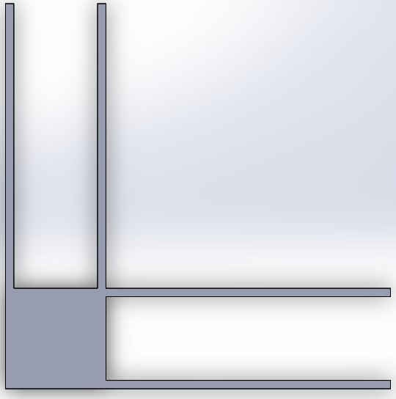

**(a)**

**(b)**

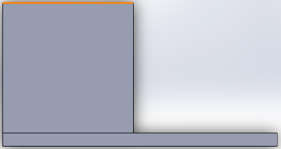

Figure 6: Individual square platforms with guide arms attached. (a) Square 9 with long guide arms in X and Y direction. (b) Square 8 with short guide arm in Y direction.

The 9th square controlled the movement of squares 3, 6, 7, and 8. For instance, by pushing the 9th square outwards, it pushed the 8th square upwards. That combined with the constraint of the bottom track enabled the 8th square to move properly. This reduced the system DOF from 8 to 4. In a similar manner, the 5th square controlled the movement of squares 2 and 4. The DOF was further reduced from 4 to 2. To eliminate the last degree of freedom, the squares 6 and 8, which were controlled by the outer square (square 9) had guide arms that aligned the middle square (square 5) to the outer squares (Figure 6(b)). Thus by moving only the 9th square, the whole array could uniformly expand and contract. See Figure 7 for the CAD assembly of the prototype.

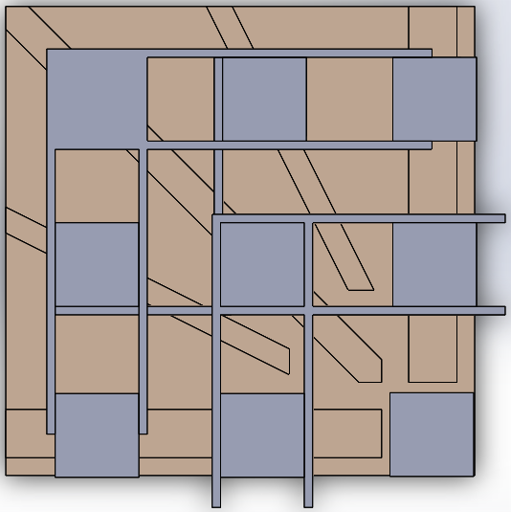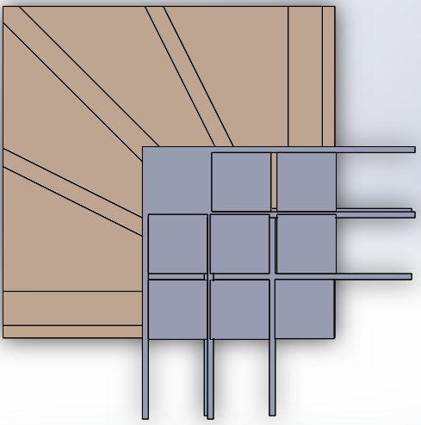

**(b)**

**(a)**

Figure 7: Full 3D CAD assembly of prototype 1. (a) Assembly in contracted state. (b) Assembly in expanded state.

Once this design was completed in SolidWorks, the components were 3D printed. See Figure 8 for the 3D printed structure.

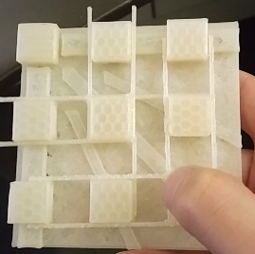

Figure 8: 3D printed model of the first prototype. Movement is controlled by square 9.

2.4 Refinements to the First Design

One key issue that was observed from printing the first prototype was the individual squares would dislodge from the base track. See Figure 9 for the side view of the track and the individual squares.

**(b)**

**(a)**

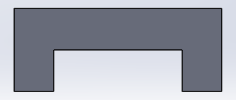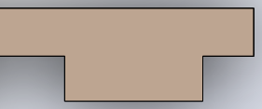

Figure 9: Side views of (a) square platform and (b) base track.

The mating between the two components (square and track) needed to be altered to restrict the movement in the z-direction. The solution implemented was changing the bottom of the square platform from a box geometry to a trapezoid geometry. The track was changed as well to mate with the square. See Figure 10 for the new cross section.

**(c)**

**(b)**

**(a)**

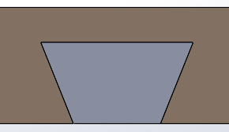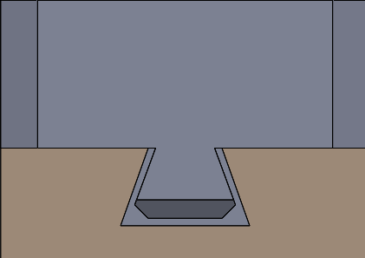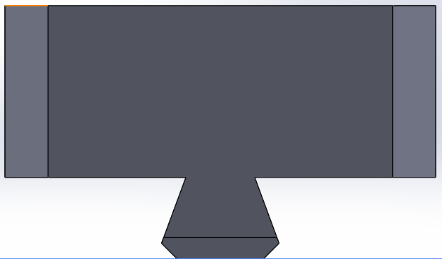

Figure 10: Updated cross section of (a) square and (b) track. (c) Mated assembly of square and track.

There was a slight offset from the square to the platform to allow the square platform to move freely while still being able to restrict the platform from being displaced from the track as shown in Figure 10(c).

The concept that was shown from the 3 by 3 LED array could be scaled bigger. The concept was redesigned and reprinted to produce a 4x4 LED array while still maintaining the 1 degree of freedom of the entire system. See Figure 11 for the scaled up prototype.

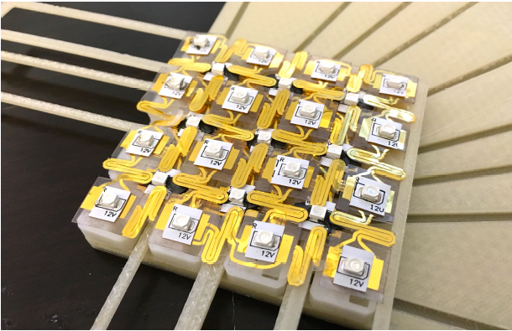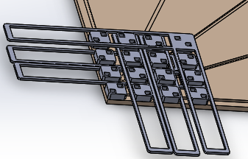

**(b)**

**(a)**

Figure 11: 4 by 4 model of the prototype. (a) CAD model. (b) 3D printed mode overlaid with LEDs.

The guide arms were redesigned. See Figure 6 for the original guide arm design. Since the arms got longer, they would be subject to a higher bending moment causing permanent deflection for the guide arm. The original guide arms were cantilever beams, which needed to be changed. An extra beam at the end of the guide arm was added for extra support. See Figure 12 for the updated guide arm design.

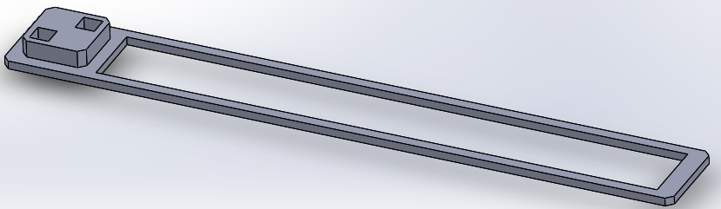

Figure 12: Updated design of the guide arms.

To prove the concept that the system had 1 DOF, a motor was attached to the outer corner square, square 9, via a rack and pinion mechanism. This moved that corner square, which in turn moved the entire 4 by 4 LED array. See Figure 13 for completed first prototype of the stretchable display with the motor module.

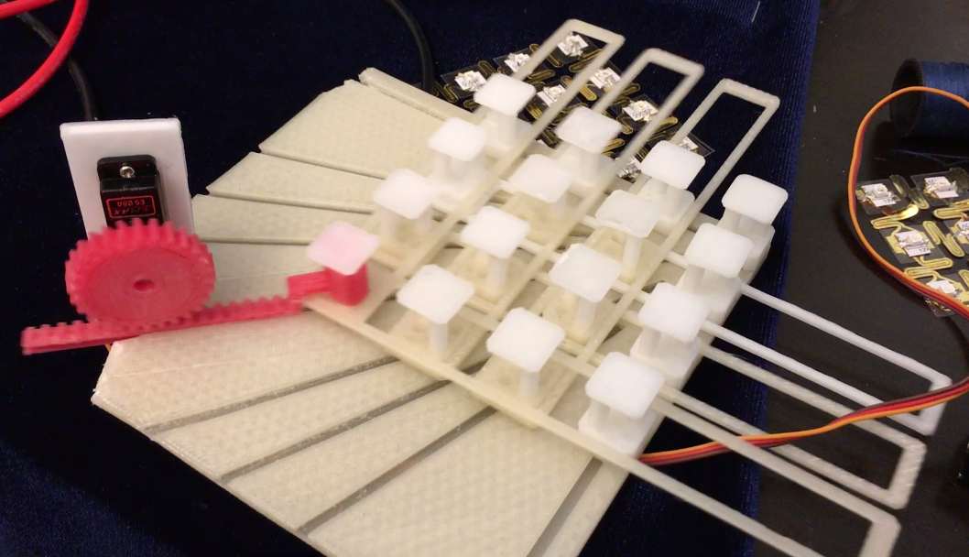

Figure 13: Updated 4 by 4 stretchable display prototype with motor configuration.

This prototype had two layers of LED arrays. The top layer had a 4 by 4 array of LEDs, where each LED was fixed to a square platform. There was a second layer of LEDs hidden below the top layer. This layer was a 3 by 3 array where the LEDs where the LEDs where connected to the top layer. The hidden layer was not connected to anything else, so they were hanging in the air. See Figure 14.

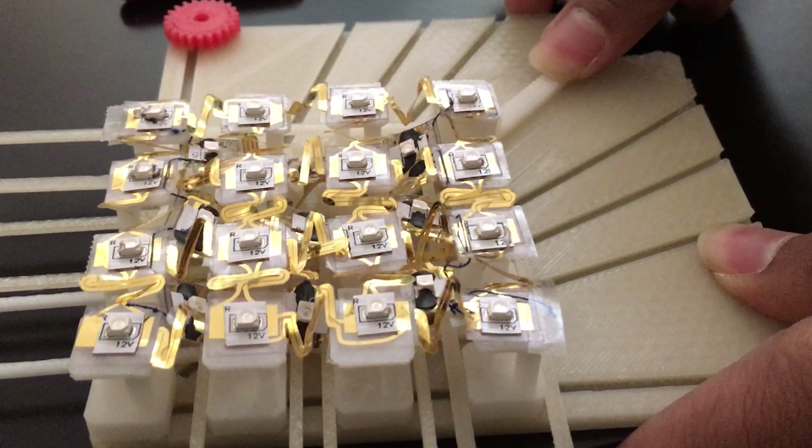

Figure 14: 4 by 4 array of LEDs attached to square platforms connected with 3 by 3 hidden array of LEDs.

When the top layer was in its contracted state, the hidden layer would be unseen. When the stretchable display expanded, the hidden layer would rise up to the top layer to partially fill the gaps that were created by the top layer expansion. The purpose for this was to demonstrate the ability to maintain screen resolution while stretching. There were several drawbacks to this first prototype, which led to the development of further prototypes.

3.0 Second Design Iteration of the Stretchable Display

These prototypes were a representation of a display, with each platform representing a pixel on a display screen. In its contracted state, there was a 4 by 4 array of LEDs seen in Figure 11(b). One issue was that the LEDs could be seen, but so could a portion of the base track and the guide arms. Ideally, only the 16 LEDs should be seen. Figure 15 shows the areas that needed to be eliminated, which was the focus of the second prototype.

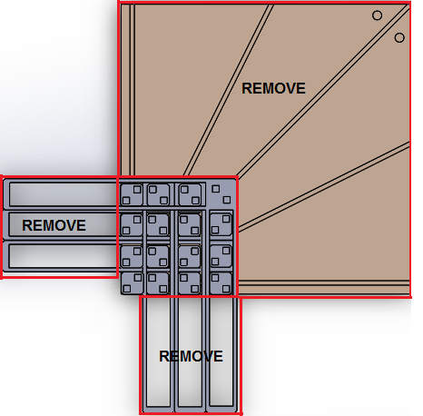

Figure 15: Areas from the first prototype that need to be removed.

3.1 First Approach to the Solution

To eliminate the extra area created by the platform, inspiration of the design came from examining a drawer slide. See Figure 16 for the drawer slide and

Figure 17 for the design concept.

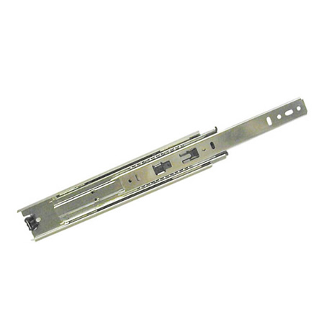

Figure 16: A Drawer slide mechanism (eDirectHardware.com) [12].

**(b)**

**(a)**

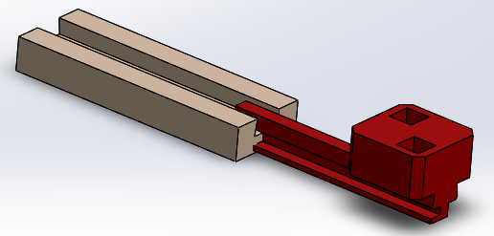

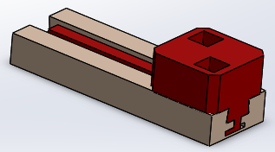

Figure 17: CAD model of revised partial track. (a) Contracted state. (b) Transition to an expanded state with a shortened base track (beige component).

The guide arm length was reduced, but the number of guide arms required were doubled to compensate. Each guide arm was connected to another guide arm and together, the two would be the equivalent of one guide arm from the first prototype (Figure 12). See Figure 18 for the revised guide arm design for the second prototype.

**(a)**

**(b)**

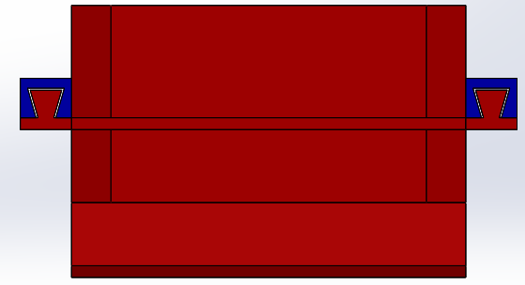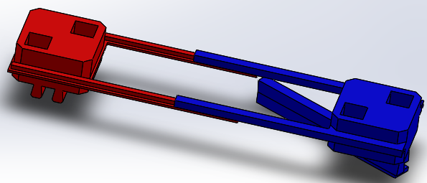

Figure 18: (a) Guide arms for prototype 2. (b) Cross section view of guide arms.

3.2 Second Approach: A Complete Redesign

After an evaluation of the progress of the second prototype, it became evident that continuing with the approach would get more complex, making it unfeasible to continue in the same direction.

Given the size of the square platform that was being used at 2 by 2 cm, the guide arms needed to have a small cross section. When the guide arms were 3D printed, it became difficult to keep the geometry as the features were too small for the 3D printer being used. Thus, the guide arms needed to be thicker. It was impractical to simply scale the guide arms bigger, because it would have created a significant gap between adjacent square platforms. This was because the guide arms were attached to the sides of the squares. The solution was to change the location of the guide arms. The guide arms were located inside the squares, where the squares contained additional extruded cuts to allow for the guide arms to pass through. Figure 19 shows the newly designed guide arms.

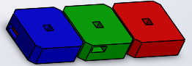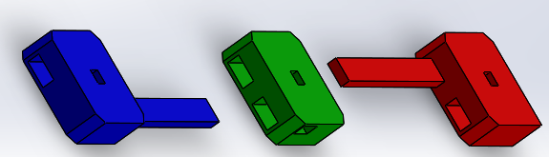

**(a)**

**(b)**

Figure 19: Redesigned guide arms by changing locations. (a) Compact view. (b) Exploded view.

The next step was to adjust the base track design. This was replaced by a much smaller track that only constrained one diagonal of the system. Figure 20 shows the new track design as opposed to the track design in the first prototype. This figure was similar to the design in Figure 17(b).

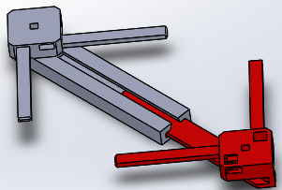

Figure 20: Updated track design for prototype 2.

For a 3 by 3 LED array, it became apparent that constraining the motion of all the squares by having a base track was not necessary. It certainly helped the assembly to move smoother, but it added extra area to the prototype that was undesirable. If the LED array were to expand further, say to a 4 by 4, this assembly would have required a second diagonal track.

This pattern could be scaled further, so if the array was n by n, it would require n-2 diagonal tracks. This was created using SolidWorks and proved to be true. Figure 21 shows the full CAD assembly. The 3 by 3 LED array was also printed and can be seen in Figure 22.

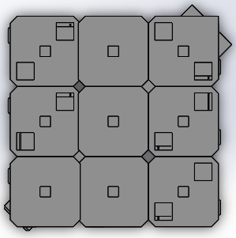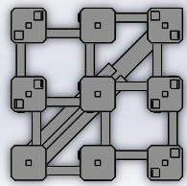

**(a)**

**(b)**

Figure 21: Full 3D CAD model of prototype 2 of the stretchable display. (a) Compact state. (b) Expanded state.

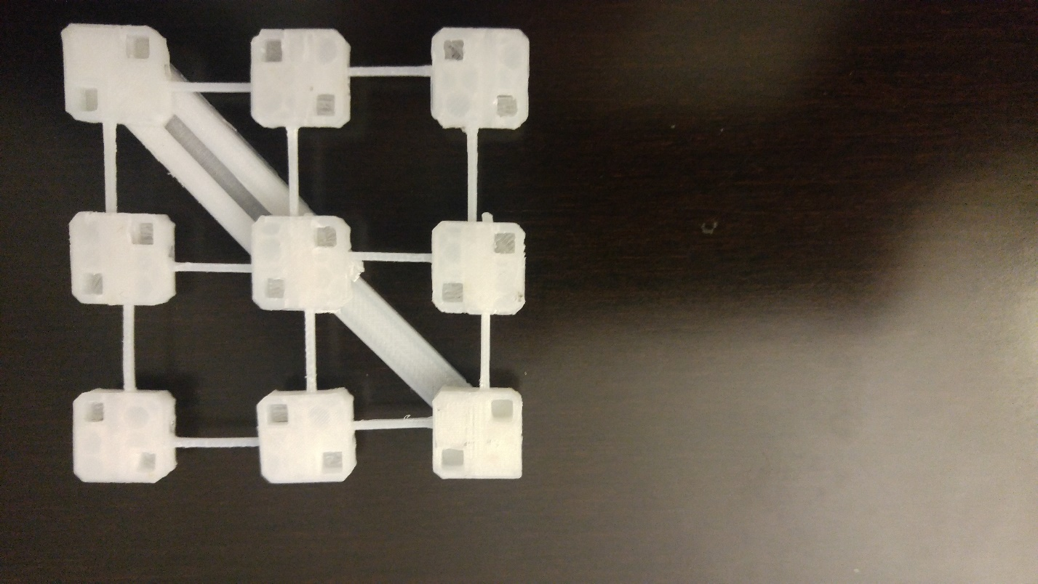

**(b)**

**(a)**

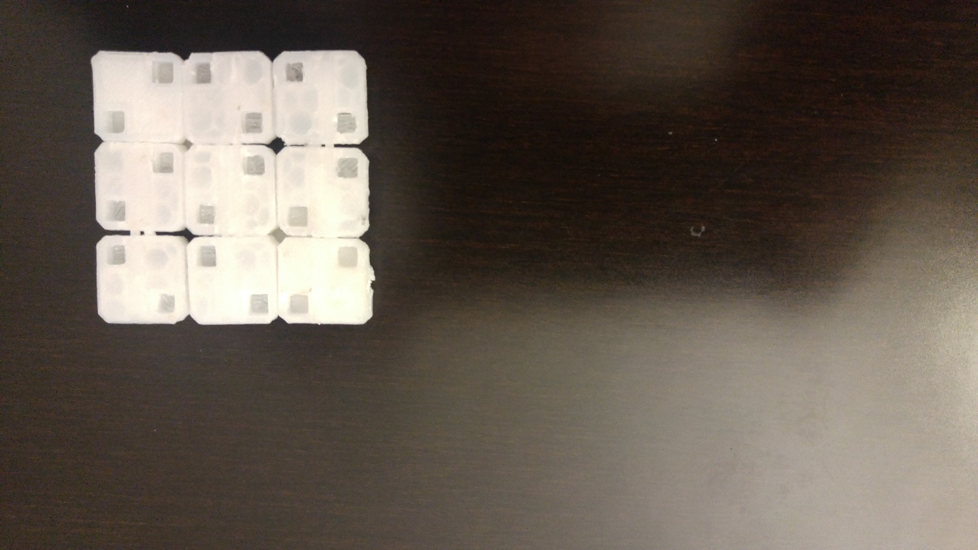

Figure 22: 3D printed model of prototype 2. (a) Compact state. (b) Expanded state. The guide arms were adjusted in the model after the print for more support.

4.0 Third Prototype of the Stretchable Display

The third, and current prototype focused towards making the prototype look like a “display”. The goal of this prototype was to have no gaps in between platforms, whether it was in contracted or expanded state. With no gaps, the display resolution of the display, regardless of state, would remain the same. When contracted, the display would be a 3 by 3 array, with the square platforms touching each other and all other components hidden below the top layer of square platforms. When expanded, the display would be a 5 by 5, where additional platforms would rise to the top layer to fill what used to be vacant areas of the display.

4.1 Visualizing the Configuration

In previous prototypes, there were not many components because the gaps were left unfilled. In this proposed prototype, the number of square platforms increased from 9 to 25 for a 3 by 3 LED array. The first step to designing this prototype was to simplify the model to just the square platforms to determine the mechanics of motion. When expanded to a 5 by 5 LED array, only one configuration exists. However, in the compact state of a 3 by 3 array, there could be multiple configurations. The top layer of 3 by 3 LEDs would have one possible configuration, but the other 16 LEDs hidden below it could be arranged in a variety of ways. See Figure 23 for the configuration that was chosen.

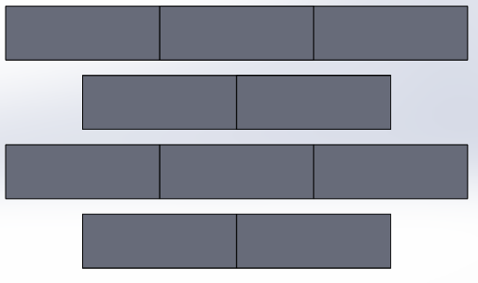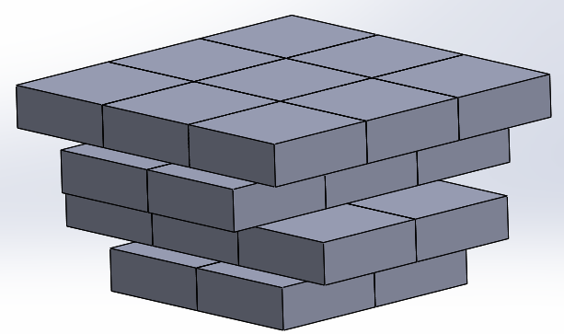

Figure 23: (a) Side view and (b) isometric view of a simplified representation of the third prototype in compact state.

**(b)**

**(a)**

This configuration was chosen because of the alignment of the hidden layers with the top layer. In this configuration, there are 4 layers of square platforms. The top layers is a 3 by 3 array, the next two layers are 2 by 3 arrays, and the last layer is a 2 by 2 array. While the assembly is transitioning from the compact 3 by 3 array to the expanded 5 by 5 array, the hidden layers would always be aligned so that they fill the gaps created by the expanding top layer.

4.2 Connecting the Four Layers Together

The layers were connected using simple mechanical linkages. All square platforms but one were connected to another platform on a different layer. See Figure 24 for the mechanical linkages between two square platforms from the top layer connected to two platforms on a secondary layer.

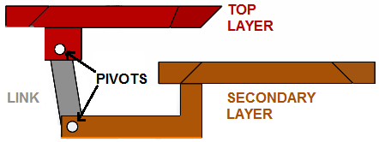

Figure 24: Mechanical link connecting between one square on the top layer to a square on a secondary layer

For each linkage (consisting of two pivot points and the linkage itself), there were three parameters to determine: The location of the two pivots and the linkage length. The parameters could be varied as long as the linkage allowed the platforms to transition from collapsed state to expanded state. These parameters gave a little bit of freedom for designing, which was very important to avoid interference between moving squares. The distances were determined in the visualization stage (section 4.1). See Figure 25 for the complete set of connections between the top layer and the second layer of platforms.

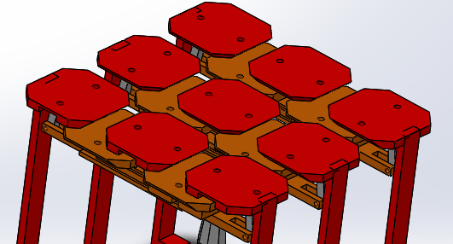

Figure 25: 6 link connections between the top layer and secondary hidden layer.

Similarly, the top layer connected to the third layer, but the connections were in a different direction than the first set of connections. To connect the fourth and final layer of platforms, they were connected to the third layer, which had an additional pivot point to accommodate for the connection. See Figure 26 for an image of a third layer square platform used to connect to the top layer as well as the bottom layer.

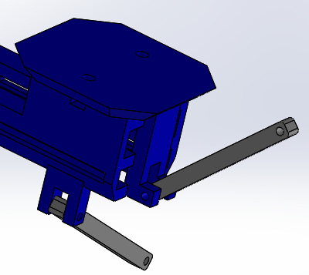

Figure 26: A square platform on the third layer, which connects to both the top layer and fourth layer of platforms.

See Figure 27 for the complete set of connections.

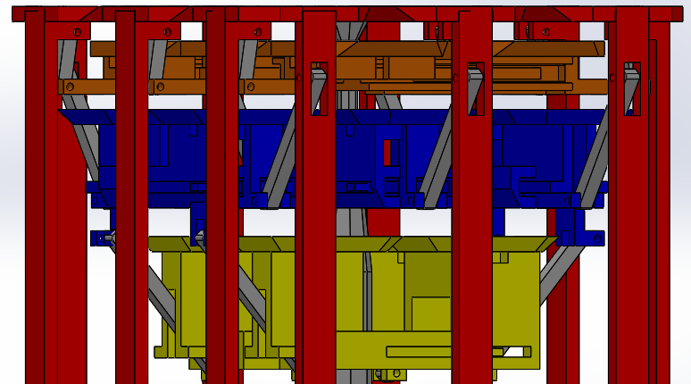

Figure 27: All square platforms connected using 16 links.

Since there were numerous moving parts, interference was an issue. As stated earlier, there was design freedom for the linkage system between two platforms. For the linkages between the top layer and the second layer, it was important to design the platforms to be as close to each other without touching. The other set of linkages were designed so they would not interfere between adjacent layers of platforms. Overall, the entire display configuration should be as thin as possible to go with the trend of modern electrical displays. Thus, the interferences between layers were very tight as seen in Figure 28.

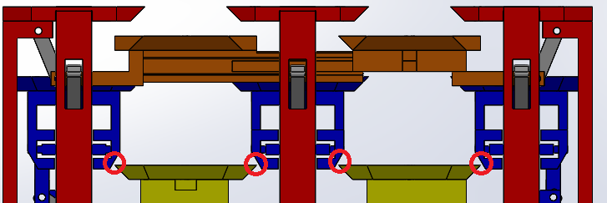

Figure 28: Assembly showing tight gaps between the third layer (blue) and the fourth layer (yellow).

Using tools in the SolidWorks suite such as *Interference Detection* and *Move Component with Physical Dynamics*, the design was tested and verified to have no interference between components. See Figure 29 for the full CAD assembly of the prototype at this stage.

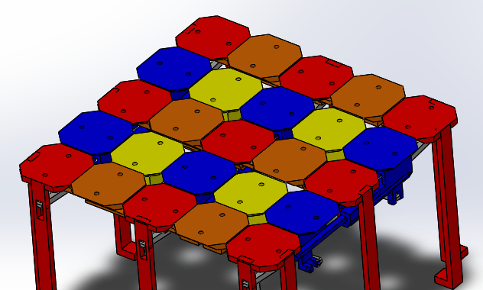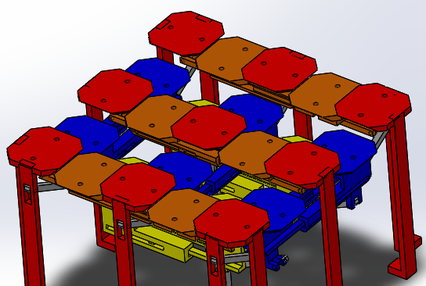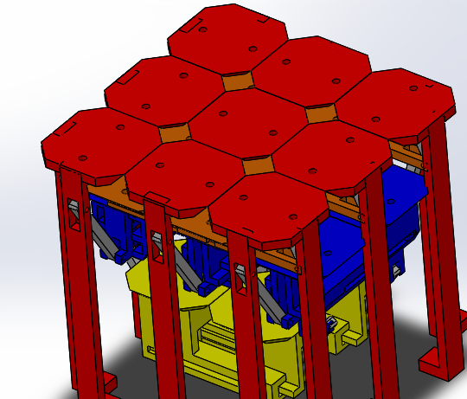

**(c)**

**(b)**

**(a)**

Figure 29: CAD model of third prototype at (a) compact state, (b) transition state, and (c) expanded state.

4.3 Implementing the Second Prototype with the Current Prototype

In Figure 29, there were “legs” that were fixed to all the top layer squares. The legs were extended to the ground to ensure that the top layer squares always remained parallel to the ground. The movement of the prototype was caused by pulling on any of the top squares, but did not expand uniformly like the previous two prototypes. Thus, the solution was to attach the design of the second prototype to each square on the top layer. See Figure 30 for the updated prototype at this stage.

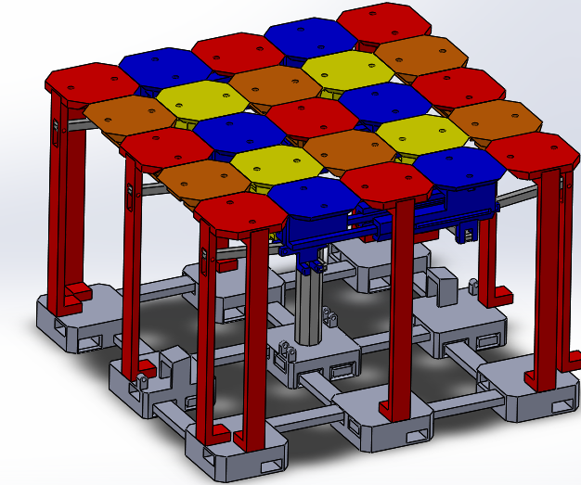

Figure 30: Third prototype updated with the base foundation from the second prototype.

Adding the second prototype served three purposes. It gave support and ground contact to the new design. Since each square platform on the top layer was rigidly connected to the second prototype, it meant the top layer would always be parallel to the ground. Lastly, it helped the configuration to expand and contract uniformly.

4.4 Bringing the Design to Real Life

Once the design seemed to be finalized, the next step in the process was to physically create it. All the designed parts were printed using the 3D printer. The material chosen was polyactic acid (PLA), a very common material for 3D printing [13]. 3D printed parts sometimes contained support material, material that was necessary for the part to be printed. See Figure 31 for an image of the 3D printer software demonstrating the required supports needed for printing.

**(a)**

**(b)**

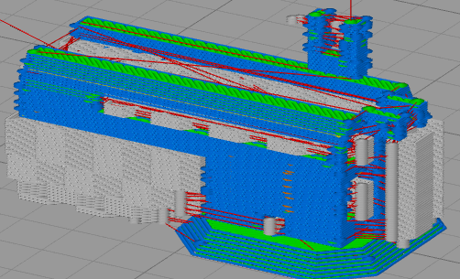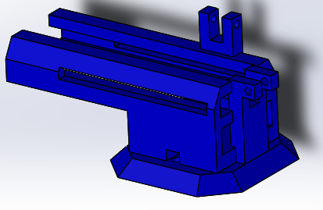

Figure 31: (a) G-code simulation of 3D printed component with support material compared with (b) 3D CAD model.

The support material needed to be removed using a combination of pliers, files, and tweezers. Depending on the design of the part, the support was necessary since 3D printing is an additive process. The printer operated from bottom up and built the part by adding material layer by layer on top of previously printed material. The support material could be avoided or reduced by changing the orientation of the part using the Simplify3D software, but some parts were unavoidable and required support material.

Another important design decision was the offset needed between mating components. These offsets were determined through trial and error of printing parts. A small offset, or no offset at all, would create a lot of friction between parts. In some cases, due to the dimensional tolerance of the 3D printer, some parts would not mate. A large offset would also cause an issue. The mating parts usually allowed the two parts to move along one plane. Having a large offset would give parts the freedom to move in more directions than intended, which would have led to misalignment. The decision was to design parts that had a relatively small offset (around 200 microns) so there would be a small amount of friction between parts. The parts would be filed down further to reduce friction as necessary. The reason for this was because subtracting from the part by filing would be easier than adding more material.

After all the parts were printed and filed, they were ready to assemble. See Figure 32 for all the 3D printed parts.

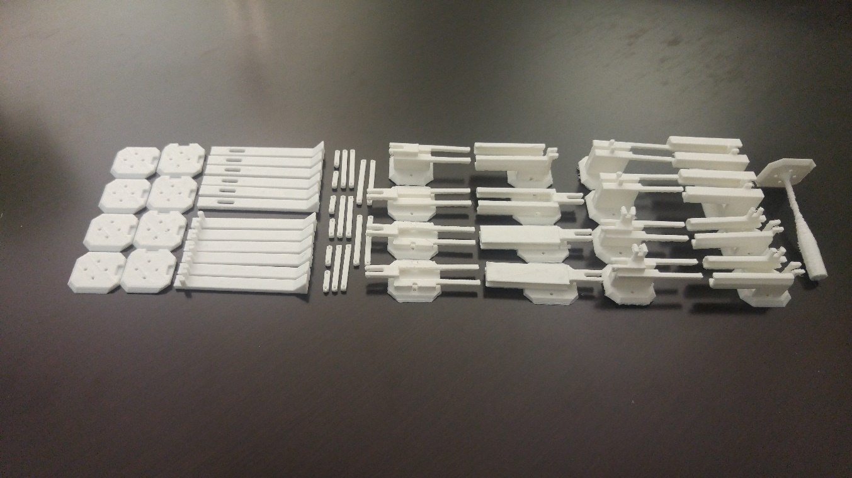

Figure 32: All 3D printed components ready for assembly of third prototype.

The linkages were assembled by inserting staples at the pivots. See Figure 33.

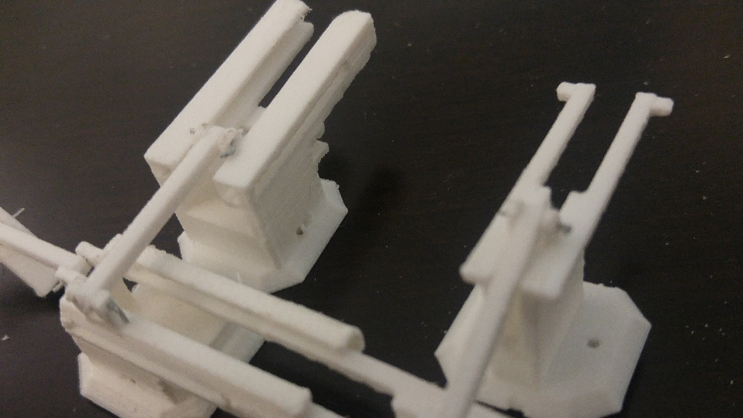

Figure 33: Part of the assembly showing the staples at the pivot points..

Other than using staples at the pivots, the other mating between parts were done through the guide tracks as shown in Figure 34.

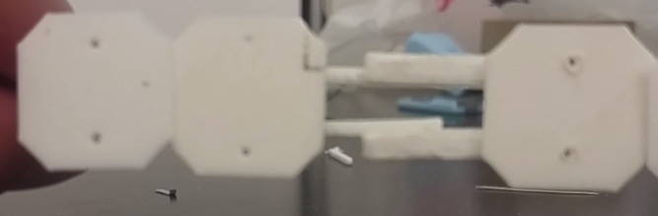

Figure 34: Guide tracks connecting two square platforms.

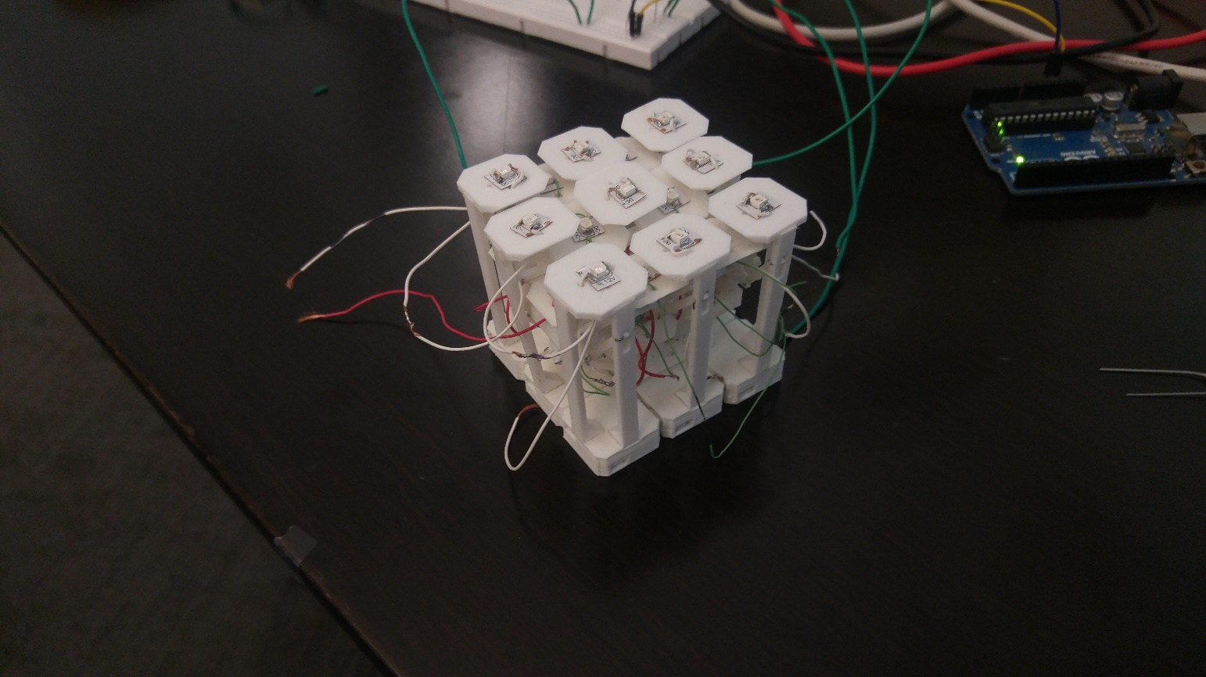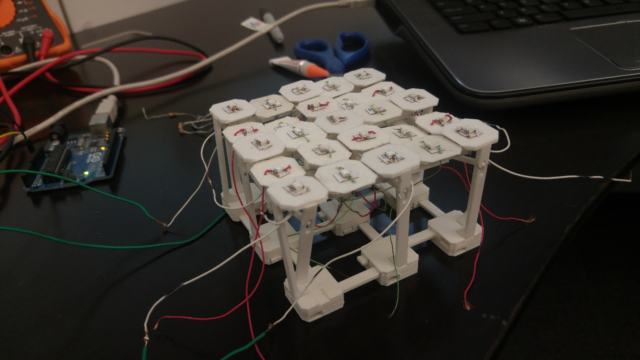 See Figure 35 for the completed 3D printed assembly of the stretchable display mechanism.

Figure 35: Fully assembled third prototype. The prototype was able to transition from (a) compact to (b) expanded state by pulling on the corners of the prototype.

**(b)**

**(a)**

4.5 Adding “Pixels”

This prototype was supposed to represent an electrical display, so one off-the-shelf LED was stuck onto one platform. The wiring had to be completed before the bottom of the prototype was attached. See Figure 36 for the LEDs and the partial wiring process.

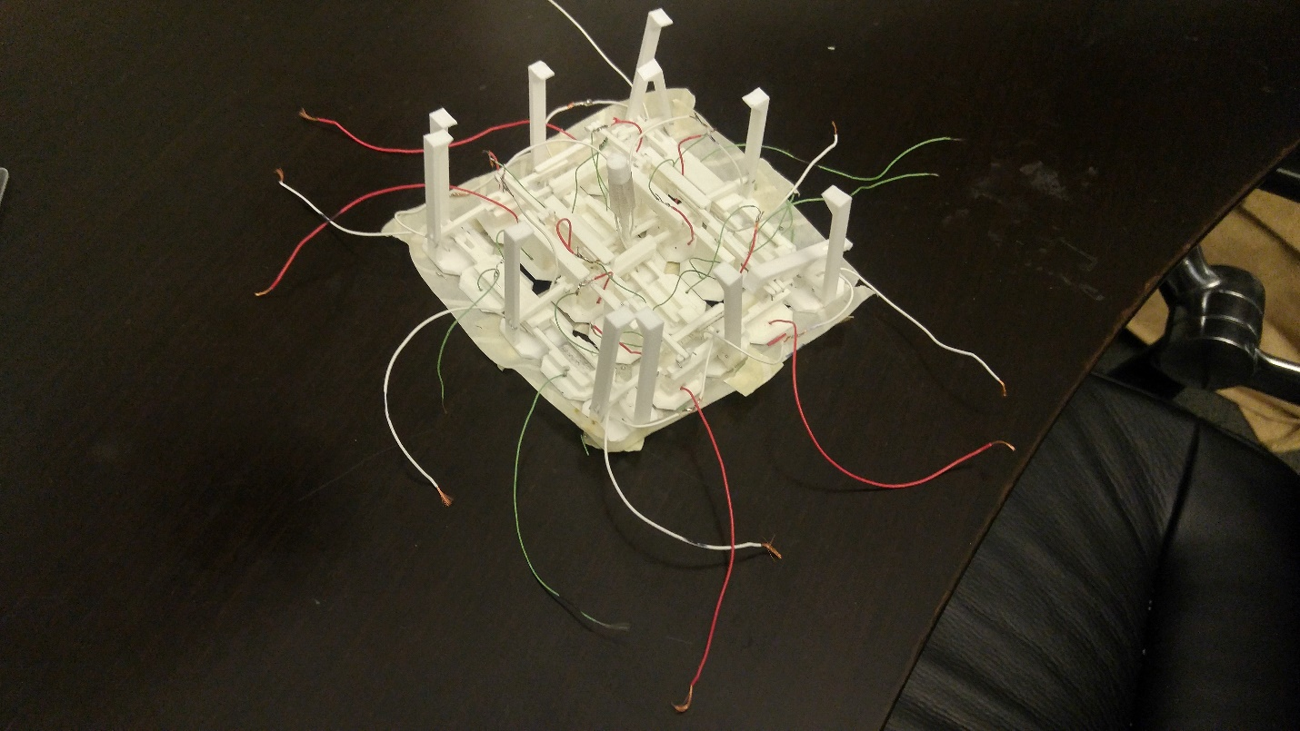

**(a)**

**(b)**

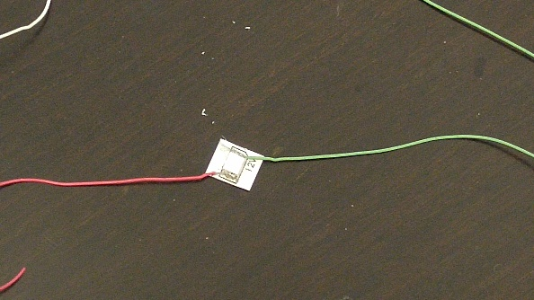

Figure 36: (a) Bottom side of prototype with partial wiring. (b) Single LED used for this prototype.

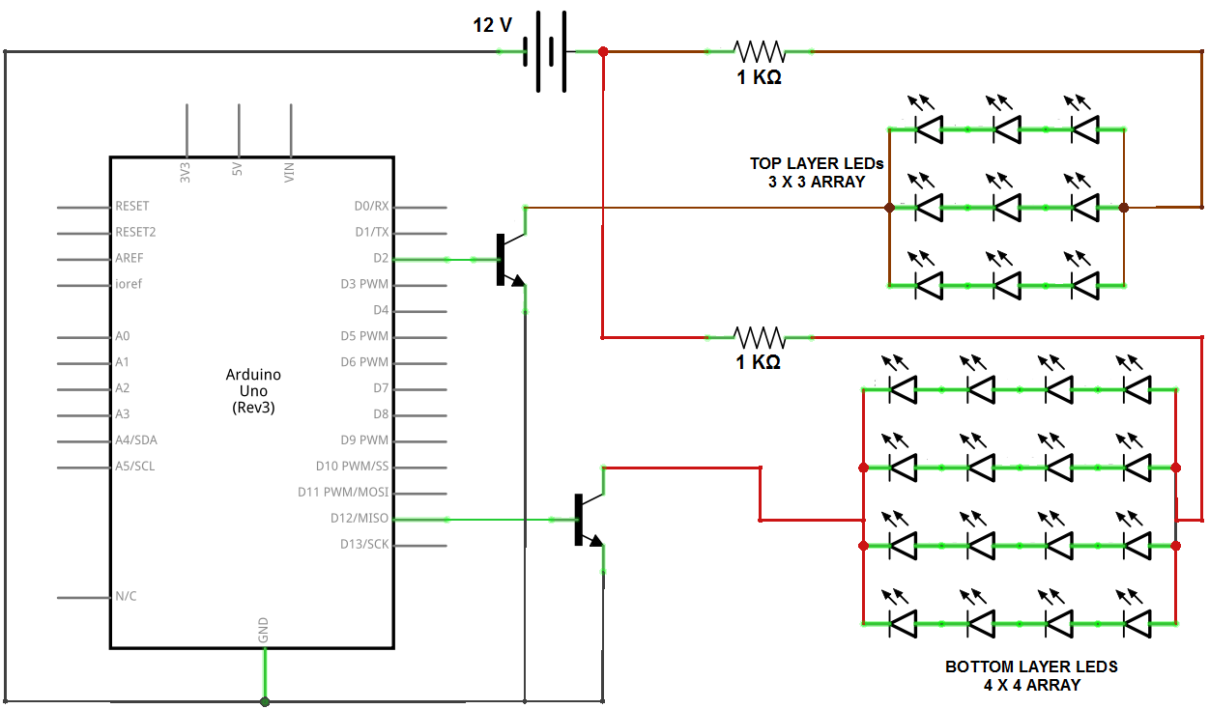The LEDs were wired so that the top layer was all connected to each other, and the bottom three layers were connected. To avoid burning of the LEDs, either three or four LEDs would be connected in series. The voltage source was set at 12V and each LED absorbed about 3V due to the internal resistance of the LEDs. See Figure 37 for the schematic diagram of the LEDs.

Figure 37: Circuit diagram of stretchable display prototype.

The two transistors were used as switches to control either the top layer or the bottom three layers. The switching of LEDs would be controlled through a microcontroller, an Arduino UNO in this case. The concept was that in compact state, only the top layer (9 LEDs) would be turned on. When the assembly was fully expanded, all LEDs would be on. See Figure 38 for the assembly in expanded state with the LEDs.

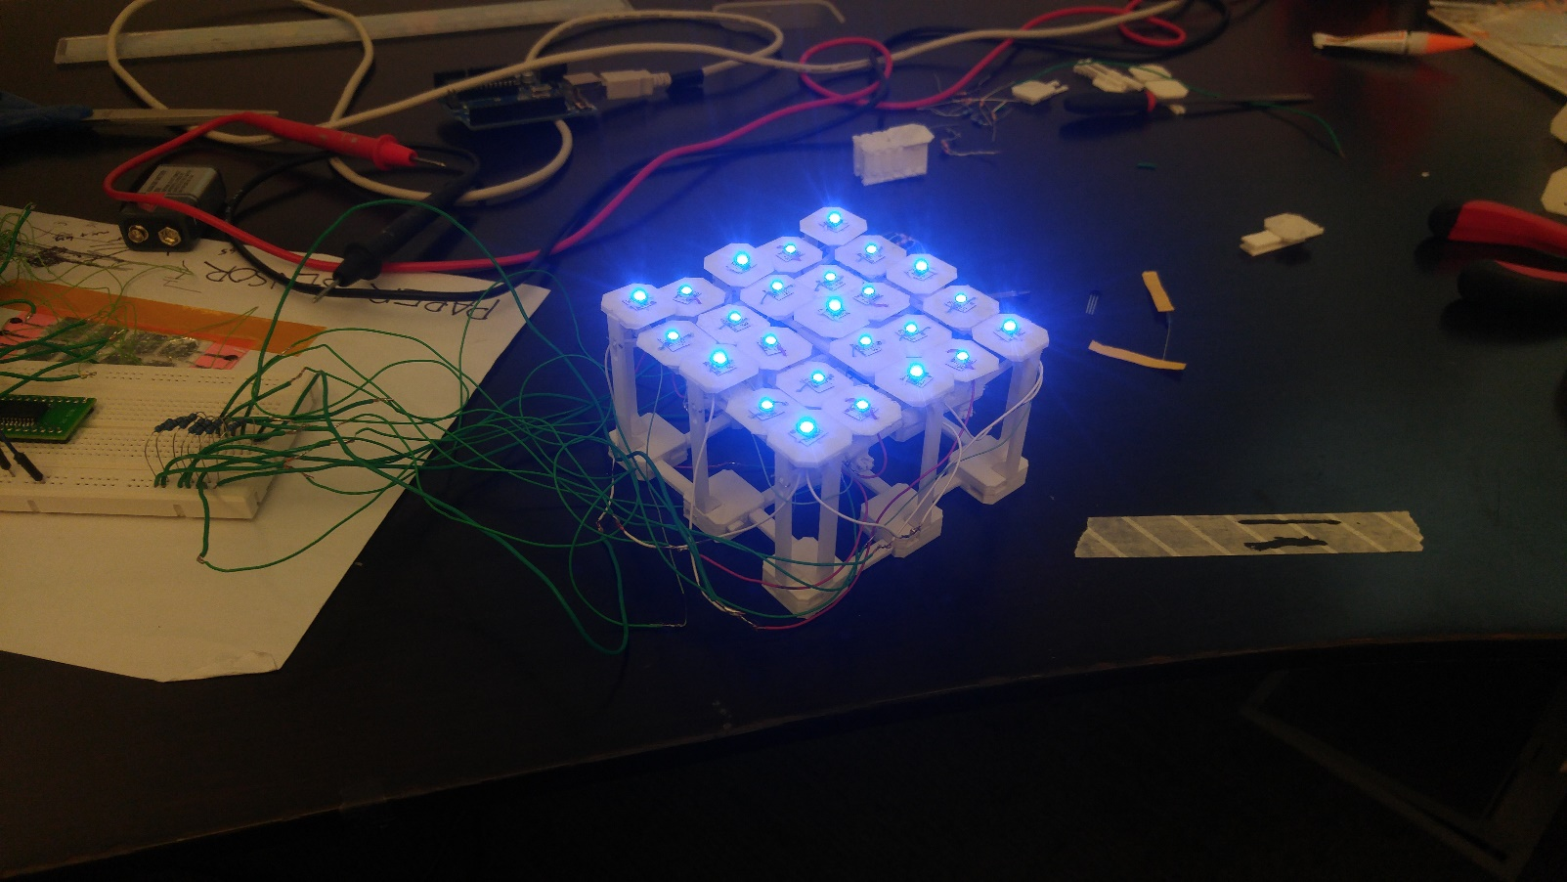

Figure 38: Stretchable Display prototype with all LEDs turned on.

4.6 Adjustments to the Prototype after the First Print

The first print did not turn out perfect. There were two significant issues that were not clear in the design phase, but came apparent once it was printed. The first problem was the loose guide track mates between the square platforms. See Figure 34 for the mates in question. The extensions on the square platforms would detach if the assembly was extended further. Once this occurred, the two square platforms would fall and it would be impossible to reattach them. To fix this, a variation of a slider-crank mechanism was introduced to prevent the two mated square platforms from detaching. See Figure 39 for the updated platform.

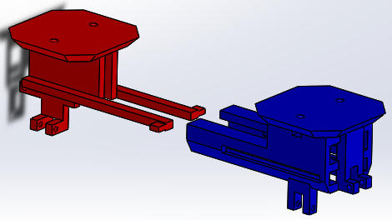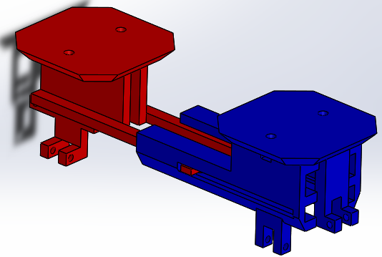

**(b)**

**(a)**

Figure 39: (a) Square platform mated with another through revised guide tracks. (b) Exploded view.

The crank was from the pivot-link point and the guide track represents the slider. This slider-crank mechanism was applied to all of the hidden layer square platforms. Once this mechanism was in place, it stabilized the configuration making it hard to detach or misalign.

The other issue that required attention was the overall leveling of the display. Ideally, displays should have an even, flat surface. In the 3 by 3 compact state, there was no problem since all the top layer platforms were connected to the base structure. In the 5 by 5 expanded state, it was difficult for some of the hidden layer platforms to rise up to the top layer. The four squares at the very bottom had the hardest time transitioning to the top. See Figure 40.

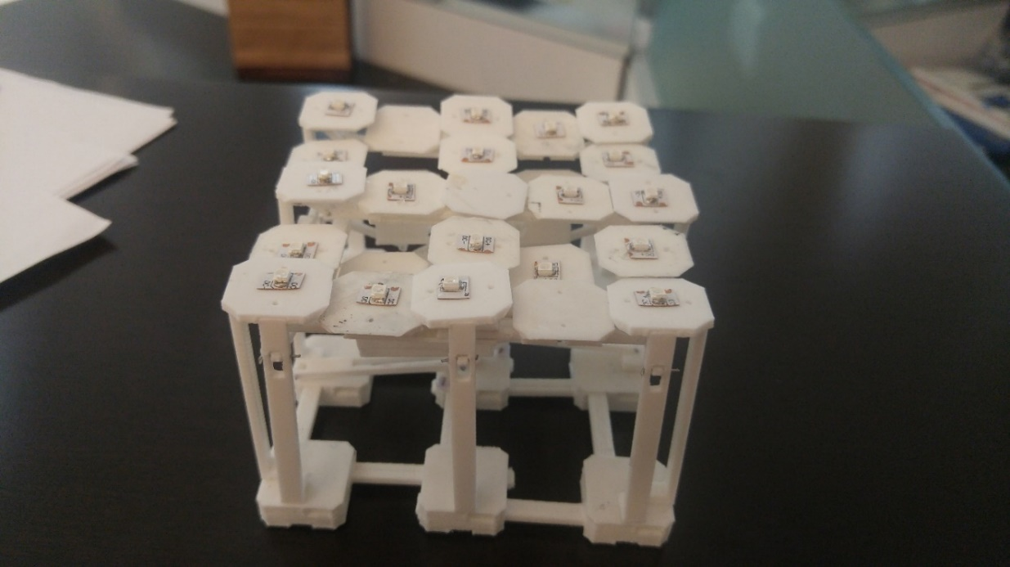

Figure 40: Un-level square platforms when platform was expanded.

The bottom four squares had trouble rising to the top because they were not directly connected to the base or top squares. The movement resulted from pulling on the top or bottom squares. The top layer had direct connections with layer 2 and 3, so those two layers had little problem to level with the top layer when expanded. The bottom layer was connected with the third layer, so pulling on the top layer did not directly translate to lifting the bottom layer. Regardless of how far the assembly expanded, the bottom four squares would not rise up fully.

To solve this, another variation of the slider-crank mechanism was utilized. The joints were fixed to the base. This mechanism’s purpose was to push the four bottom squares vertically. This vertical actuation would occur when the distance between two of the base platforms increased. This was implemented with the prototype, and functioned as planned. See Figure 41 for the partial CAD model and Figure 42 for the 3D printed component integrated with the prototype.

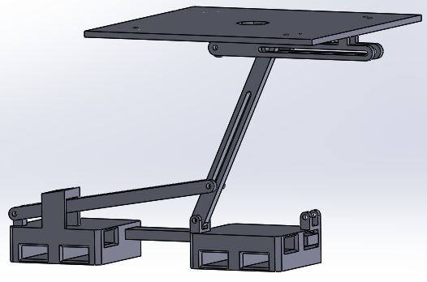

**(b)**

**(a)**

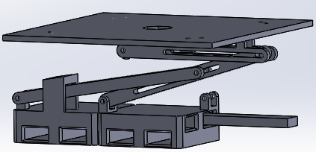

Figure 41: Partial CAD model of the vertical actuator support mechanism.

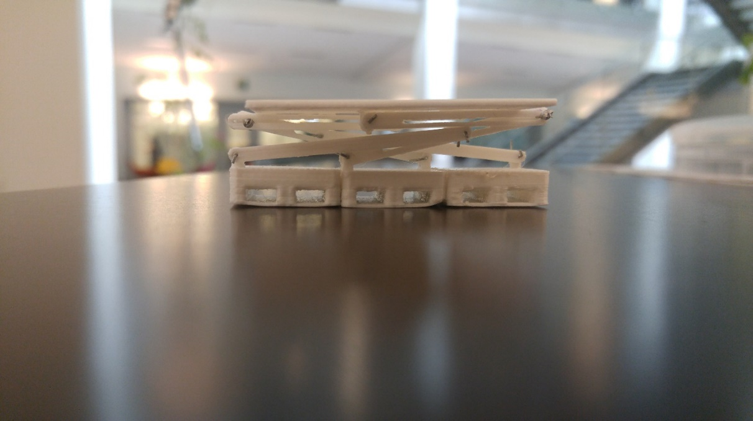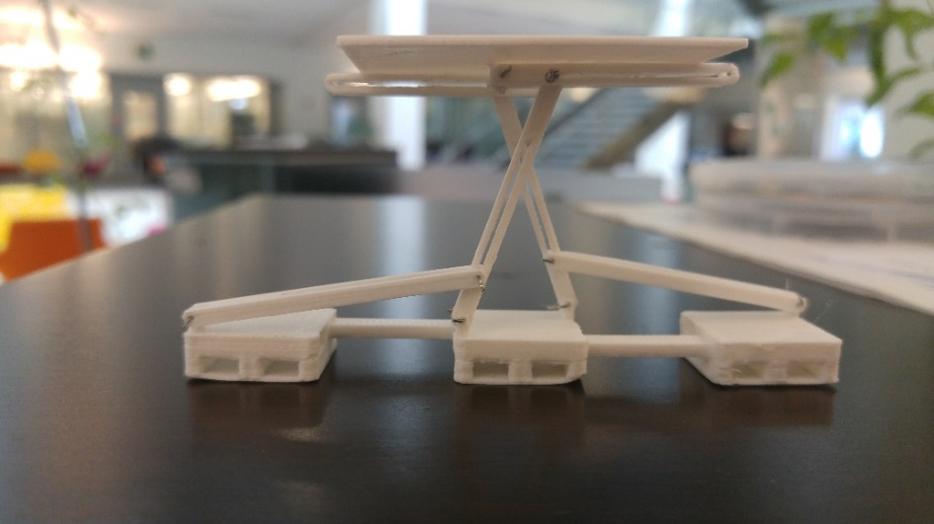

**(a)**

**(b)**

Figure 42: 3D printed vertical actuating support subassembly. (a) Compact state. (b) Expanded state.

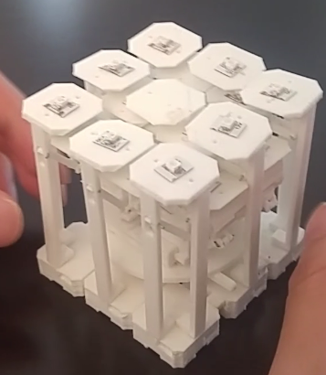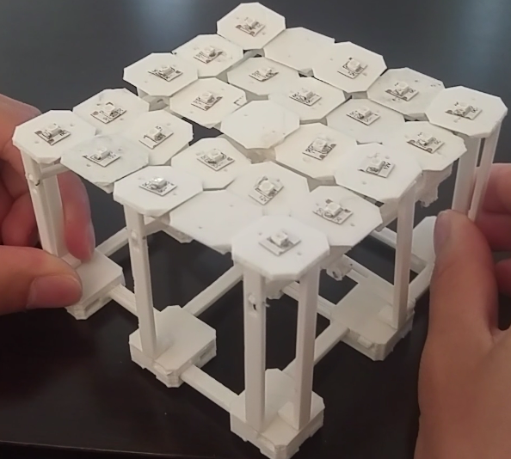The most updated, and final, version of the third prototype can be seen in FIGURE. The final prototype was capable of expanding from 3 by 3 to 5 by 5 by pulling on the corners of the stretchable display mechanism.

**(a)**

**(b)**

Figure 43: Final stretchable display prototype transitioning from (a) compact to (b) expanded state by pulling on the corners.

5.0 Conclusions

To date, nobody has developed and commercialized a stretchable display. State of the art electrical displays are all rigid. Research has started to make progress toward stretchable displays by embedding LEDs on stretchable material allowing them to change shape. The approach to the stretchable display for this concept was unconventional. Using rigid, 3D printed material to produce a stretchable display is more advantageous in terms of structural support, increased stretchability, intact display resolution, and durability.

The prototype design went through three main stages. The first stage was to create a prototype that would allow for uniform expansion and contraction of the system. The second stage was to refine the first prototype stage by reducing the starting area. The last stage was to fill the gaps with extra square platforms while the system expanded to main display resolution.

This final prototype presented in the report is not a functional electrical display. It presents a unique approach to creating a stretchable display prototype, vastly different from what other research groups are attempting. A prototype like this, which maintains display resolution, combined with other stretchable display concepts focused on LEDs on flexible substrates, might just lead to the creation of a commercialized stretchable display.

6.0 Recommendations

Below are four recommendations for future iterations of the prototype.

6.1 Automated Prototype

The first prototype was an automated mechanism, controlled by a motor. If the final prototype could have a servo motor transitioning from a 3 by 3 to a 5 by 5 LED array, it would replicate how a functional stretchable electronic display would work. Since the servo motor can be controlled through a microcontroller, it would be easy to identify whether the array was in compact or expanded state. With this information, the microcontroller could switch the LEDs depending on the state. The motor attachment would most likely attach to the base of the assembly similar to the first prototype.

6.2 Reducing Prototype Thickness

When compact, the assembly was as tall as it was wide. For a real electronic display, it is impractical for it to be a cube. Future designs of this mechanism would need to reduce the thickness of the stretchable display prototype.

6.3 Further Stretchability

With the final design, there was a limitation to how far it could stretch. The length of the current display went from 3 units to 5 units. If scaled, this design would stretch from n units to (2n-1) units. Thus, the maximum increase in length would be approximately doubled. This design cannot stretch further, so if the requirement were to increase the stretchability of the display, a complete redesign would be required.

6.4. Increasing “Pixel” Density

An electronic display is filled with thousands to millions of pixels with very little space between pixels. The majority of the space covered by the platform was whitespace, and not much “pixel” coverage. To improve this, more LEDs could be added to the platform. Instead of one LED on each platform, there could be a total of 9 LEDs on one platform. See Figure 44 for what this would look like.

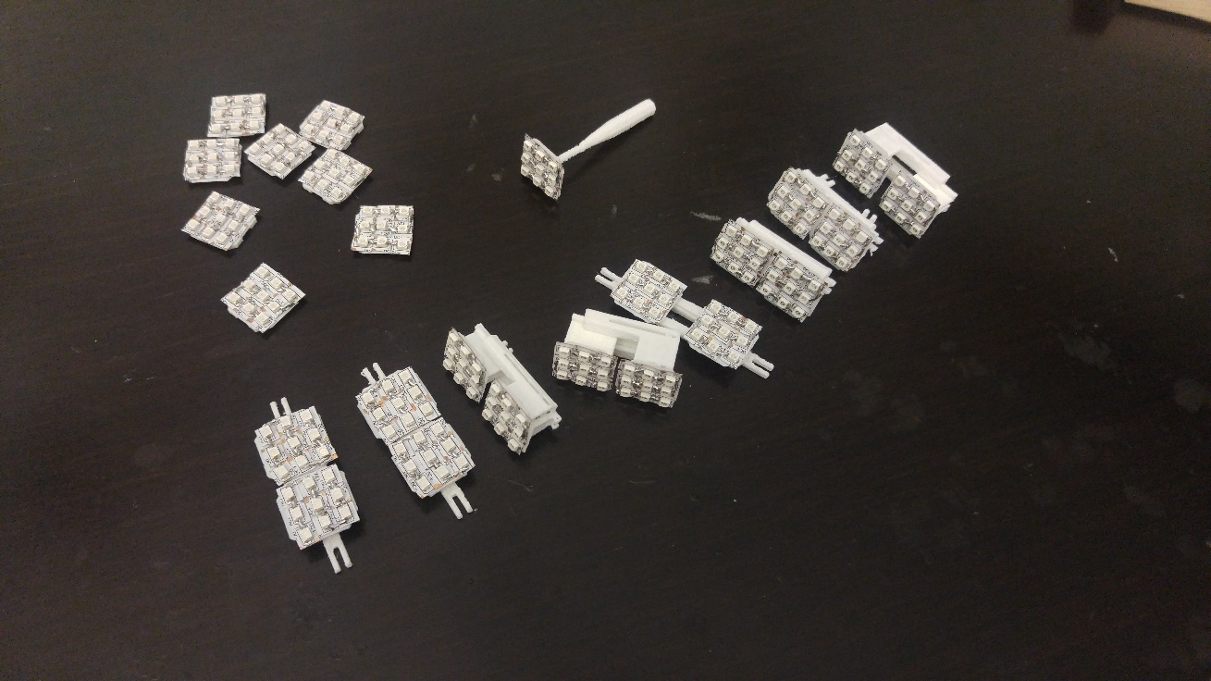

Figure 44: Square platforms saturated with 9 LEDs each.

This increased pixel coverage would make it look more like a display. The type of LED could be changed to a smaller LED to fit even more LEDs. The small LEDs could be wired using a PCB for each platform to reduce the amount of wires required. Current display technology has focused on OLEDs, so that could be the next step for this prototype.

7.0 References

1. Lee, H.J. (2016, Feb 1). *Curved Displays Continue to Rise in Popularity*. Samsung Semiconductor USA. Retrieved from http://www.samsungsemiblog.com/displays/curved-displays-continue-to-rise-in-popularity/
2. Eadicicco, Lisa. (2015, Apr 2). *Samsung's new phone with a curved screen is absolutely gorgeous, but there's one problem*. Business Insider. Retrieved from http://www.businessinsider.com/galaxy-s6-edge-review-2015-4
3. Griffiths, Sarah. (2015, Sep 16). *Samsung's 'Foldable Valley' could launch in January: Flexible phone uses a bendy plastic display to open and close like a book*. The Daily Mail. Retrieved from http://www.dailymail.co.uk/sciencetech/article-3236809/Samsung-s-Foldable-Valley-launch-January-Flexible-smartphone-uses-bendy-plastic-display-open-close-like-book.html
4. Ricker, Thomas. (2010, May 26). *Sony’s Rollable OLED display can wrap around a pencil, our hearts (video).* Engadget. Retrieved from http://www.engadget.com/2010/05/26/sonys-rollable-oled-display-can-wrap-around-a-pencil-our-heart/
5. Brueck, Hilary. (2016, Feb 17). *See the smartphone that can bend, not break.* Fortune Magazine. Retrieved from http://fortune.com/2016/02/17/reflex-bendable-smartphone/
6. Rogers, J., Someya, T., Huang, Y. (2010, Mar 26). *Materials and Mechanics for Stretchable Electronics.* Science, 327, 1603-1607. doi:10.1126/science.1182383
7. Hu, X., Krull, P., de Graff, B., Dowling, K., Rogers, J., Arora, W. (2011, Apr 29). *Stretchable Inorganic-Semiconductor Electronic Systems*. Advanced Materials, 23(26), 2933-2936. doi:10.1002/adma.201100144
8. Sekitani, T. et. al. (2009, May 10). *Stretchable active-matrix organic light-emitting diode display using printable elastic conductors*. Nature Materials, 8, 494-499. doi:10.1038/nmat2459
9. Palermo, Elizabeth. (2013, Sep 19). *Fused Deposition Modeling: Most Common 3D Printing Method*. Live Science. Retrieved from http://www.livescience.com/39810-fused-deposition-modeling.html
10. Sculpteo. (n.d.). *Solidworks 3D Tutorial: Prepare your model for 3D Printing with Solidworks*. Retrieved 2016 May 8 from https://www.sculpteo.com/en/tutorial/prepare-your-model-3d-printing-solidworks/
11. Ultimaker. (2011, Nov 24). *What is G-Code?* Retrieved 2016, May 8 from the Ultimaker Wiki: http://wiki.ultimaker.com/What_is_G-Code
12. eDirectHardware. (2015). *Full Extension Drawer Slides*. Retrieved 2016, May 8 from httpwww.edirecthardware.comarticlesfull-extension-drawer-slides.html
13. Powell, Isaac. (2011, Nov 11). *ABS or PLA? Choosing the right filament.* Make Magazine. Retrieved from http://makezine.com/2014/11/11/abs-or-pla-choosing-the-right-filament/